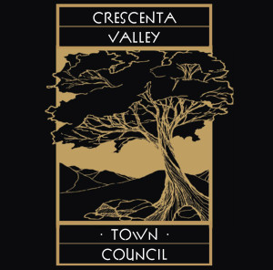
General Meeting Agenda
September 20, 2018
La Crescenta Library Community Room 7:00 pm
www.theCVcouncil.com or contact@thecvcouncil.com

Welcome to the monthly meeting of the CV Town Council.
Please turn off or silence cell phones while inside the Council meeting

- Call to Order & Welcome
- Flag Salute
- Invocation
- Roll Call.
- Approval of August General Meeting Minutes
- Approval of September agenda.

- Community Announcements (2 minute)
- Youth Council.
- Library, Marta Wiggins
- Park & Rec
- Prom Plus/Firehouse
- Friends of Rockhaven
- VFW/American Legion
- Community Reports (2 min and questions)
- Sheriff
- Los Angeles County Fire.
- CHP
- GUSD
- CV Chamber
- CVWD
- CV Cert
- CV Ready /CV Fire Council
- CVCA
- Los Angeles County Park and Rec will present to the council and the community the Final Rendering for the Median Tree project at Two Strike Park (Committee Recommendation, action item)
- Los Angeles County Public Work Will Present the Arroyo Verdugo Communities Joint Power Authority. (Measure M)
- Call-Trans will present to council and the community the Noise Reading Study Result for the sound walls
- CVWD presentation about the water quality
- LUC -Committee report.

- Public Comments
Public Comments and Community Announcements: This is for non-agenda items only. Please submit a speaker card to the President or Vice President. Speakers are allowed 2 minutes. Council may ask questions or respond to the speaker but there will be no debate or decision. The President may refer the matter to the appropriate committee for investigation and report.

- Council Business.
- Correspondence
- Treasurer
- Sagebrush
- Pancake breakfast
- Streets & Roads/ transportation
- Website
- Dept Park and Rec Two strike park tree project
- Bylaw change (action item)
- Announcements

- Adjourn

